18.47: Express Eq. (18.33) as 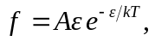 with A a constant. Then,

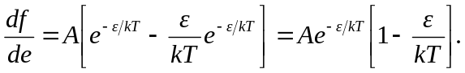

Thus, f will be a maximum when the term in square brackets is zero, or 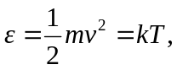 which is Eq. (18.34).

